**Angular Advance 1**

**2 way binding(Input/Output Properties):**

Suppose:

app:parent component,test:child component

app.comp.ts

App.comp.html

Now child component:

Test.comp.ts

Test.comp.html

**Lifecycle hooks:**

App.comp.ts

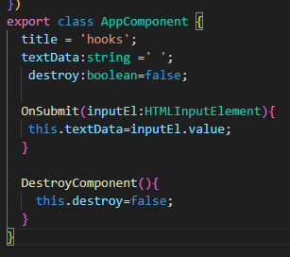

App.comp.html

Demo.comp.html

<div class="demo">

    <p>hey starting with lifecycle hooks.the test tou enterd will be shown here:{{ value }}</p>

    <ng-content></ng-content>

</div>

Demo.comp.ts

Implemented all hooks



